Sales and Expense analysis

Problem Statement :

Analys the Sales and Expense of the company. Chek the trend over Year and month. Alog with channel, store, continent and product. Check average sales and expenses. Which product is repeated mostly. Give your insights to increase the sales and overcome the expenses, product.

(note : This data is not real data, I got this data from my IIM skills instructor.)

ER Diagram of Database

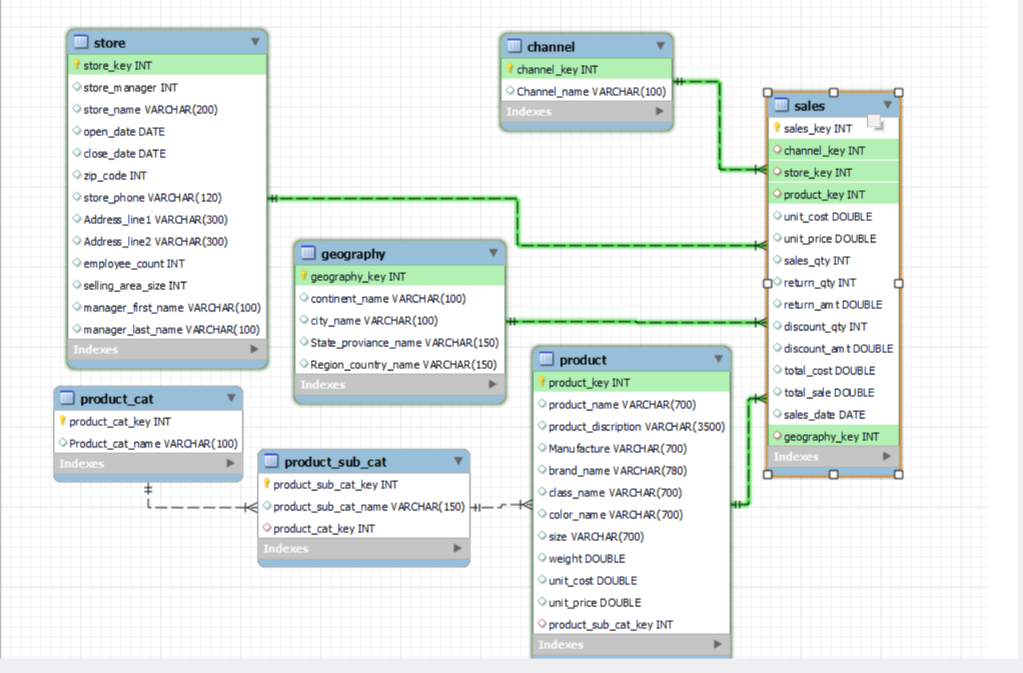

Q. What we have?

We Have total 7 Tables which are related to each other. Sales is our main table. We also have the tables like channel, geography, store and product with two more table (product sub cat, product cat).

Channel table : gives the information of channel from which sales made.

Geography table : gives the information of location where the sales was made.

Product table : give the information of product, from which product we made sales.

Product Sub Cat table : give the information of product subcategory.

Product Cat table : give the information of product category.

All the fields along with the table are provided in the bottom of this project.

Calculating

1. Total Sales.

SELECT

total_sale,

ROUND(unit_price * sales_qty, 1) AS calculated_sales

FROM

sales;

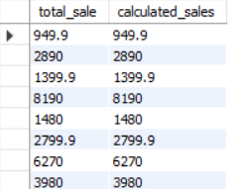

SELECT

ROUND(SUM(total_sale),2) as total_sales

FROM

sales;

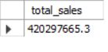

1. Total Expense
2. Total cost

SELECT

ROUND(SUM(total_cost),2) as total_cost

FROM

sales;



1. Total Discount amount

SELECT

ROUND(SUM(discount_amt), 2) AS total_discount_amt

FROM

sales;



1. Total Return amount

SELECT

ROUND(SUM(return_amt), 2) AS total_return_amt

FROM

sales;

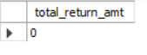

Total Expenses :

SELECT

ROUND(SUM(return_amt), 2) +

ROUND(SUM(discount_amt),2)+

ROUND(SUM(total_cost), 2) AS total_expenses

FROM

sales;



1. Net Profit

SELECT

ROUND(ROUND(SUM(total_sale), 2) - ROUND(SUM(return_amt) + SUM(discount_amt) + SUM(total_cost), 2), 2) AS net_profit

FROM

sales;

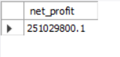

1. Total Expenses, Total Sales over Year

SELECT

YEAR(sales_date) AS sales_year,

ROUND(SUM(return_amt), 2) + ROUND(SUM(discount_amt), 2) + ROUND(SUM(total_cost), 2) AS total_expenses,

ROUND(SUM(total_sale), 2) AS total_sale

FROM

sales

GROUP BY YEAR(sales_date)

ORDER BY sales_year;

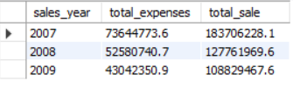

1. YTD Sales, YTD Expense (Year to Date)

( last or recent year sales and expenses)

SELECT

YEAR(sales_date) AS sales_year,

ROUND(SUM(return_amt), 2) + ROUND(SUM(discount_amt), 2) + ROUND(SUM(total_cost), 2) AS total_expenses,

ROUND(SUM(total_sale), 2) AS total_sale

FROM

sales

WHERE YEAR(sales_date) =2009

GROUP BY YEAR(sales_date)

ORDER BY sales_year;

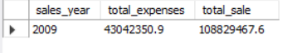

1. PYTD Sales and Expenses (Previous year sales and expenses)

SELECT

YEAR(sales_date) AS sales_year,

ROUND(SUM(return_amt), 2) + ROUND(SUM(discount_amt), 2) + ROUND(SUM(total_cost), 2) AS total_expenses,

ROUND(SUM(total_sale), 2) AS total_sale

FROM

sales

WHERE YEAR(sales_date) = 2008

GROUP BY YEAR(sales_date)

ORDER BY sales_year;



**(Note: for expenses I am using the attribute total cost because other values are equal to 0)**

**Q) Find the total sales and expenses over month.**

SELECT

MONTHNAME(sales_date) AS month_name,

ROUND(SUM(total_sale), 2) AS Total_sales,

ROUND(SUM(total_cost), 2) AS Total_expense

FROM

sales

GROUP BY MONTHNAME(sales_date),MONTH(sales_date)

ORDER BY MONTH(sales_date);

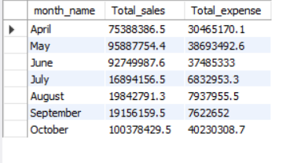

**Q) Which month have the maximum sales?**

SELECT

MONTHNAME(sales_date) AS month_name,

ROUND(SUM(total_sale), 2) AS Total_sales

FROM

sales

GROUP BY MONTHNAME(sales_date)

ORDER BY Total_sales DESC LIMIT 1;



(ADVANCE QUERIES)

**Product**

**Q) Find Top 10 product which having maximum sales ?**

SELECT

product_name, ROUND(SUM(total_sale), 2) AS total_sales

FROM

product

JOIN

sales

ON product.product_key = sales.product_key

GROUP BY product_name

ORDER BY total_sales DESC

LIMIT 10;

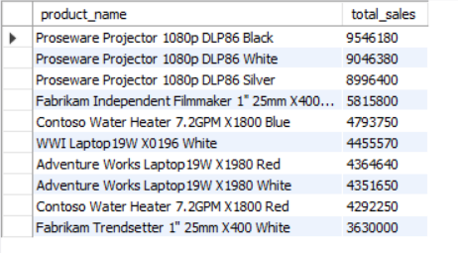

**Q) How many products we sold ? also find the total sales and expenses over them give your conclusion on them.**

i) SELECT

COUNT(product_key) AS total_product

FROM

product;

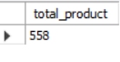

ii)

SELECT

COUNT(sales_key) AS product_demand,

product_name,

ROUND(SUM(total_sale), 2) AS total_sales,

ROUND(SUM(total_cost), 2) AS total_expense

FROM

sales

JOIN

product ON sales.product_key = product.product_key

GROUP BY product_name

ORDER BY product_demand ASC LIMIT 10;

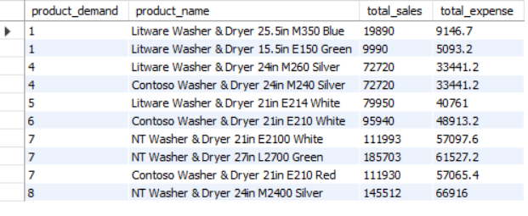

We saw than there are some Product which having the less demand but very good profit margin, which I display above. don’t make those products with high quantity always kept this product with minimum quantity.

**Q) Find the total sales and expense over the product category.**

SELECT

Product_cat_name,

ROUND(SUM(total_sale), 2) AS Total_sales,

ROUND(SUM(total_cost), 2) AS Total_cost

FROM

product_cat

JOIN

product_sub_cat ON

product_cat.product_cat_key = product_sub_cat.product_cat_key

JOIN

product ON

product_sub_cat.product_sub_cat_key = product.product_sub_cat_key

JOIN

sales ON product.product_key = sales.product_key

GROUP BY Product_cat_name

ORDER BY Total_sales DESC;

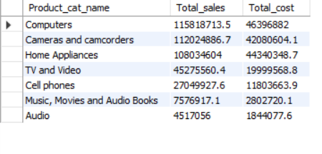

**Including all the tables**

**Q) Find the total sales, total expenses done through which channel.**

SELECT

Channel_name,

ROUND(SUM(total_sale),2) as Total_sales,

ROUND(SUM(total_cost),2) as Total_expenses

FROM

channel

JOIN

sales ON channel.channel_key = sales.channel_key

GROUP BY Channel_name;

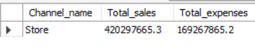

**Q) Which store is most demanded and its total sales and total expenses along with the selling place.**

SELECT

continent_name,

store_name,

COUNT(*) AS cust_prefer_store,

ROUND(SUM(total_sale), 2) AS Total_sales,

ROUND(SUM(total_cost), 2) AS Total_cost

FROM

sales

JOIN

store ON sales.store_key = store.store_key

JOIN

geography ON geography.geography_key = sales.geography_key

GROUP BY continent_name , store_name

ORDER BY cust_prefer_store DESC;

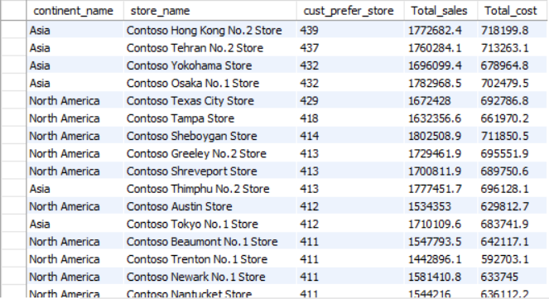

Output 2 :

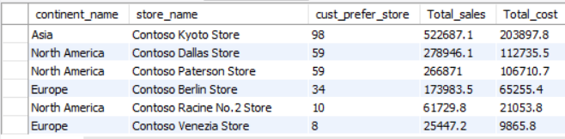

There are some stores which having very less number of customer attention along with its places.

**Q) Find the Total Sales and expenses over continent.**

SELECT

continent_name,

ROUND(SUM(total_sale),2) AS Total_sales,

ROUND(SUM(total_cost),2) AS Total_cost

FROM

geography

JOIN

sales ON geography.geography_key = sales.geography_key

GROUP BY continent_name

ORDER BY Total_sales DESC;

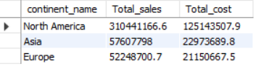

**Q) Find the total sales, total expenses over cities of Asia.**

SELECT

city_name,

ROUND(SUM(total_sale), 2) AS total_sales,

ROUND(SUM(total_cost),2) as total_expense

FROM

sales

JOIN

geography ON sales.geography_key = geography.geography_key

WHERE geography.continent_name = "Asia"

GROUP BY city_name

ORDER BY total_sales DESC;

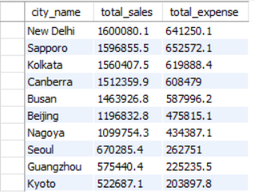

**Q) What is the Average sale? Also find average sales over year.**

SELECT

ROUND(AVG(total_sale),2) AS avarage_sale

FROM

sales;

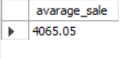

SELECT

YEAR(sales_date) AS sales_year,

ROUND(AVG(total_sale), 2) AS avg_sales

FROM

sales

GROUP BY YEAR(sales_date)

ORDER BY sales_year ASC;

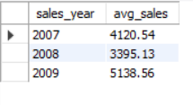

Tables

Sales Table

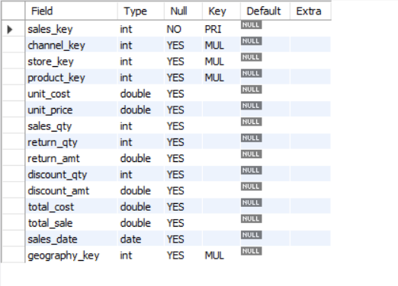

Channel Table

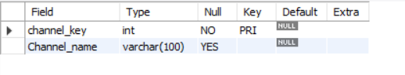

Geography Table

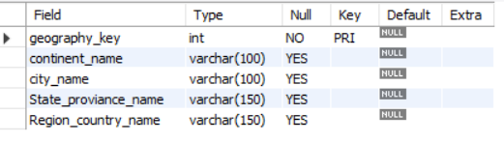

Store Table

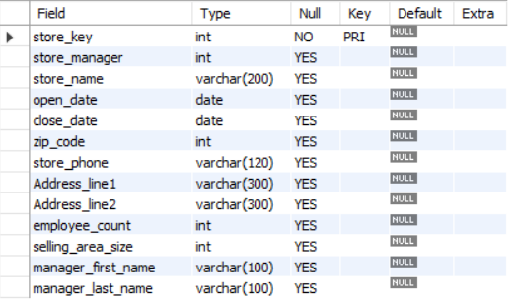

Product Table

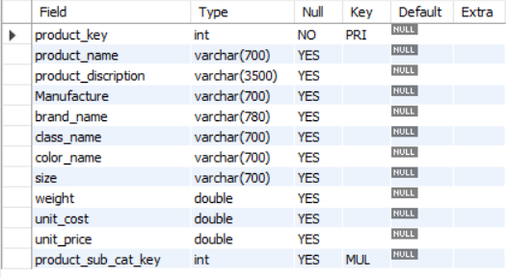

Product Sub Cat Table (product subcategory table)

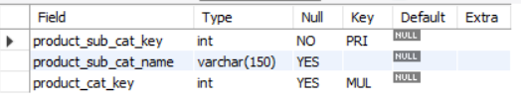

Product Cat Table (product category table)

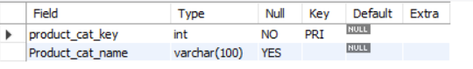

-------------------- ----------------------- -- -------- x- x - x -------------- ----------------------------- ----------